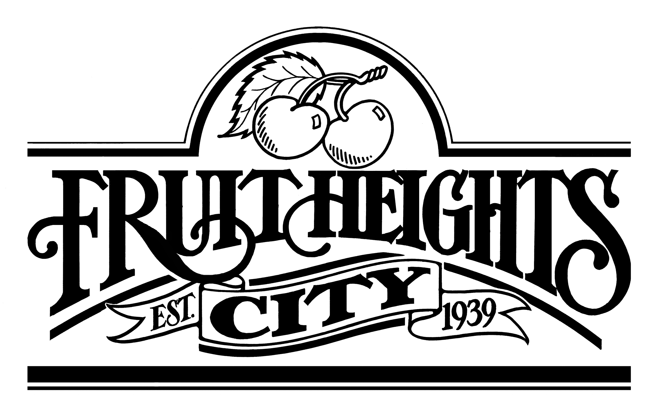
“75”
YEARS

RIDGERUNNER

FEBRUARY 2014

Happy 75th Anniversary!
Mayor, Don Carroll

As the New Year is upon us I am excited about where we are as a City. We have no debt, we have some of the lowest fees and taxes in the county, we have a wonderful staff that keeps us safe and our city beautiful. We have seen some moderate growth and with it we have some wonderful new neighbors.

Several weeks ago, we said good bye to Mayor Stevenson and Council member Bette Hubrich and welcomed two new members to the City Council. I would like to publicly express my thanks and appreciation to Mayor Stevenson and Council member Hubrich for all of the many hours each of them have spent on behalf of the City. Their influence and impact will be felt for many years to come. I am excited to work with our existing Council members Craig Hill, Eileen Moss, and Diane Anderson, and look forward to working with our new Council members Julia Busche and Scot Poole.

The citizens of Fruit Heights never cease to amaze me. In the recently completed elections, Fruit Heights City had the highest percentage voter turnout in the county (34% of registered voters) and in several cases we had a higher actual voter turnout than cities much larger than ours. I applaud those citizens who exercised their right to vote. We live in a time where it is easy to sit back and complain about the government and our leaders and then choose not to participate in the voting process. Our citizens have shown that this is not the case in Fruit Heights and I would like to thank everyone who participated in the last election process.

2014 marks the 75th anniversary of our city and throughout the year we will be having activities and commemoration events culminating with our Founder’s Day celebration on August 2nd. There is a rich history in our City and we would like to share that with each of our citizens as we celebrate this exciting event. If you have any stories, photographs, or memorabilia that you would like to share with the citizens please contact one of the City staff or one of the Council members. I am very proud to be a resident of this great city and as I go to various meetings with other mayors in our county, it is a privilege to represent each of you.

In 2013 we were able to successfully complete two large public works projects. The completion of lower Nicholls road and the modification of the intersection at Main Street and Hidden Valley Drive will add both safety and function to our

infrastructure. These public works projects are a necessary part of making sure our citizens are safe and that our streets and infrastructure are in working order. We understand that these projects are an inconvenience to those who live and travel through them. Our goal moving forward on all public works projects is to have better communication about the scope of the project, the impact to the residents, and the duration of the project. Hopefully this will allow those most affected to have a clear picture of the project and what impact it will have on them. We will be posting this information on our city website so that everyone can understand what the projects are and what the impact will be. If you ever have concerns or questions about the projects, please feel free to contact any member of the Council or myself.

Communication is critical in our ever changing world. As a City we need to do a better job communicating with our residents. There have been some significant changes to our web site and I would encourage each of you to visit it at https://www.fruitheightscity.com. We will be making additional changes to the website and our other social media so that we can make it easier to get information from and communicate with the City staff and Council. Our Facebook page is: http://www.fruitheightscity.com/facebook; and our Twitter link is: https://twitter.com/FruitHeightsGov.

We are very excited about the development of a new trail system at Nicholls Park in Fruit Heights. Our trails and parks committees have spent several years in developing plans to utilize this space. We are now in a position to put those plans into place. We have had dozens of Eagle Scout and service projects in the hollow that have helped us to get to the point we can now move forward with the development. This project when completed will be a treasure for our city and one that all of our residents can use and be proud of. We encourage continued support and will need many more volunteers to complete this wonderful project. Please follow the project on our web page.

Last year we worked very hard to establish a City sponsored curbside recycling program here in the city. We held several public meetings and gathered information from our citizens that indicated to us that they were interested in a community sponsored recycling program. We requested bids from five companies and ultimately selected a company to run our City sponsored program. A separate third party recycling company operating within our City represented themselves as if they were the official Fruit Heights City recycling program and the resulting miscommunication and confusion has led us to put our City sponsored recycling program on hold.

I would just like to thank all of those citizens who quietly pick up an overturned garbage can, help a neighbor in need, re-paint a city sign, or volunteer to be on one of our many committees. Our citizens are wonderful and it is no wonder Fruit Heights is a “City of Good Neighbors”. We are the envy of our neighboring communities. Let us enjoy our 75th anniversary together.

If you have any questions or concerns, please feel free to email me at dcarroll@fruitheightscity.com or call me on my cell phone at 801.682.3560.
MAILBOXES

Mailboxes should be able to withstand the weight of a heavy snow when snowplows push the snow from the street. Mailboxes can be pushed over from heavy snow being plowed, particularly vinyl which becomes brittle in cold weather; cast aluminum; deteriorated wood poles underground; and improper placement of poles behind the curb can all be factors.
The box should be attached securely to the post, with the front of the mailbox EVEN WITH THE BACK EDGE OF THE CURB. The bottom of the box must be 44-48 INCHES ABOVE THE ROAD PAVEMENT.

EMERGENCY PREPAREDNESS
Classes will be held on the 4th Thursday of each month at 7:00 pm in the lower level of the Fruit Heights City Building. The City building is located at 910 S. Mountain Rd. Please use the south sidewalk around the building and into the west-side doors of the lower level. Classes will provide demonstrations, recipes, and ideas on how to use the following items. I know you will learn new things if you attend. The class schedule is as follows:
January - Beans
February - Oats, Rice, and Potatoes
March - Wheat (pancakes, muffins, and other wheat ideas)
April - Dry Milk
May - Bread Making
June- Water

Please mark your calendars now for these classes so you won't miss any of them. Everyone is welcome. Bring family, friends, neighbors with you!

HEALTH DEPARTMENT OFFERING RADON KITS
Radon seeps into home through fractures in the foundation and other entryways in the infrastructure. Although radon is more likely to reach high levels in a home with a porous foundation, any home can be susceptible to radon infiltration. Utah department of Environmental Quality tracks radon test results by zip code. Purchasing a test kit is an easy, inexpensive way to find out what the radon levels are in a home. Kits can be ordered online for $7 for Utah residents at www.radon.utah.gov/
or can be purchased at most local hardware stores. The Davis County Health Department also provides free-of-charge radon testing for county residents. For more information, please go to www.daviscountyutah.gov click on Search, enter: Radon, or call 801-525-5128.

Interest by residents to have a community garden in the city was made.
A Master Gardener has offered to coordinate the efforts. City Manager Brandon Green suggested the city-owned property north of Mountain Circle. The city owns three acres at that location. If you have an interest, please email City Manager Brandon Green at: bgreen@fruitheightscity.com

“GREENS” ONLY

S A T U R D A Y
APRIL 26TH
8:00A – 3:00P
**ONE SITE**
CITY STORAGE YARD
1024 E. Nicholls Road
Across from the entrance to the
Davis Park Golf Course

TRI-CITY EMERGENCY PREPAREDNESS FAIR

Fruit Heights City will be hosting a Tri-City Emergency Preparedness Fair for the citizens of Farmington, Kaysville and Fruit Heights on May 3, 2014 from 10:00 am to 2:00 p.m. at the Fruit Heights City Bldg.; Church of Jesus Christ of Latter Day Saints Church (across from City bldg.); and the Westminster Presbyterian Church. For more information please contact Jim Crismer at jimcrismer@comcast.net, or 801-725-7063.

Ceramic Water Filter by Just Water™
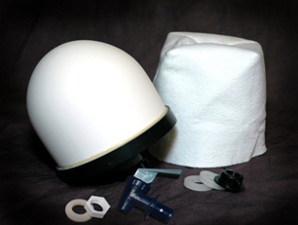
Don’t get caught without enough drinking water during an extended emergency. Storing sufficient water for your family is difficult. At least one gallon per person per day is needed for cooking and personal sanitation. The Just Water ™ ceramic filter is an inexpensive and effective method of providing water for your family. Water from a stream, lake or spring is poured into the top bucket, purified through a ceramic filter; then drips slowly into the bottom bucket that has a spigot for convenient use. More information can be found on: http://www.justwater.me/ or on the city website: www.fruitheightscity.com (Emergency Preparedness)
Cost: $35.00. Payment in advance is required. Please make checks payable to “Bob Fowler” Includes: One Ceramic filter, a spigot, straining sock, and two-4 ¼ gallon food-grade, Bisphenol A (BPA)-free buckets with lids. If you’re interested in purchasing a water purification system, please send a note to Bob Fowler, Emergency Preparedness Specialist, UtahPlanner41@gmail.com or call him at 801-299-9224.

